Points and Regions

We put 5 points on a circle and join these points with straight lines:
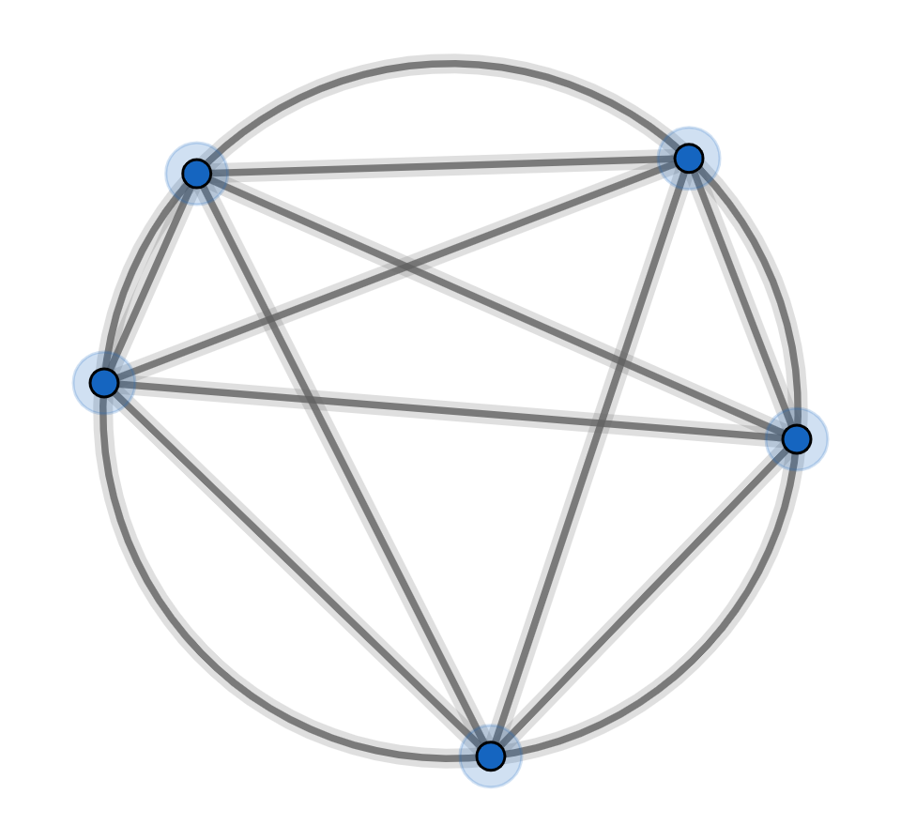

This divides the circle into a maximum of 16 regions (count them)
Note: to get the maximum number of regions, we must not allow three or more lines to cross at the same point.

If you draw diagrams and count the regions then you will find:
number of points on a circle | 1 | 2 | 3 | 4 | 5
maximum number of regions | 1 | 2 | 4 | 8 | 16

Instead of drawing diagrams and counting the regions, let’s calculate.
What is the maximum number of regions with 5 points on a circle?

Think of the lines as edges and the regions as faces and put a vertex wherever two lines or a line and the circle intersect and we have a planar graph.
As we are not counting the region on the outside, Euler’s formula becomes

Let’s calculate the number of vertices:
(a) There are 5 points on the circle. That’s 5 vertices.
(b) For every choice of 4 points on the circle, you can draw two lines that intersect.
There areways to choose 4 points on the circle so there are 5 lines that intersect giving us another 5 vertices.
So

Let’s calculate the number of edges:
(a) There are 5 points on the circle. Each of these points is attached to 6 edges.
That’sedges. No!
Each edge is shared with two points.
So that’sedges.
(b) There arepoints where two lines intersect. Each of these points is attached to 4 edges.
That’sedges. No!
Each edge is shared with two points.
So that’sedges.
So

Let’s calculate the number of faces:
soas expected.

Repeat this calculation for 6 points on the perimeter. You should find there are 31 regions. (surprised?)

Repeat this calculation forpoints on the perimeter.
Let’s calculate the number of vertices:

Let’s calculate the number of edges:

Let’s calculate the number of faces:

You can simplify this to:
Or if you prefer:

